**Assisted Practice: 3.7 Delete an EBS Volume**

This section will guide you to:

* Delete an EBS volume

This lab has three subsections, namely:

3.7.1 Selecting the EBS volume you want to delete

3.7.2 Deleting the volume

3.7.3 Pushing the file to GitHub repositories

**Step 3.7.1:** Selecting the EBS volume you want to delete

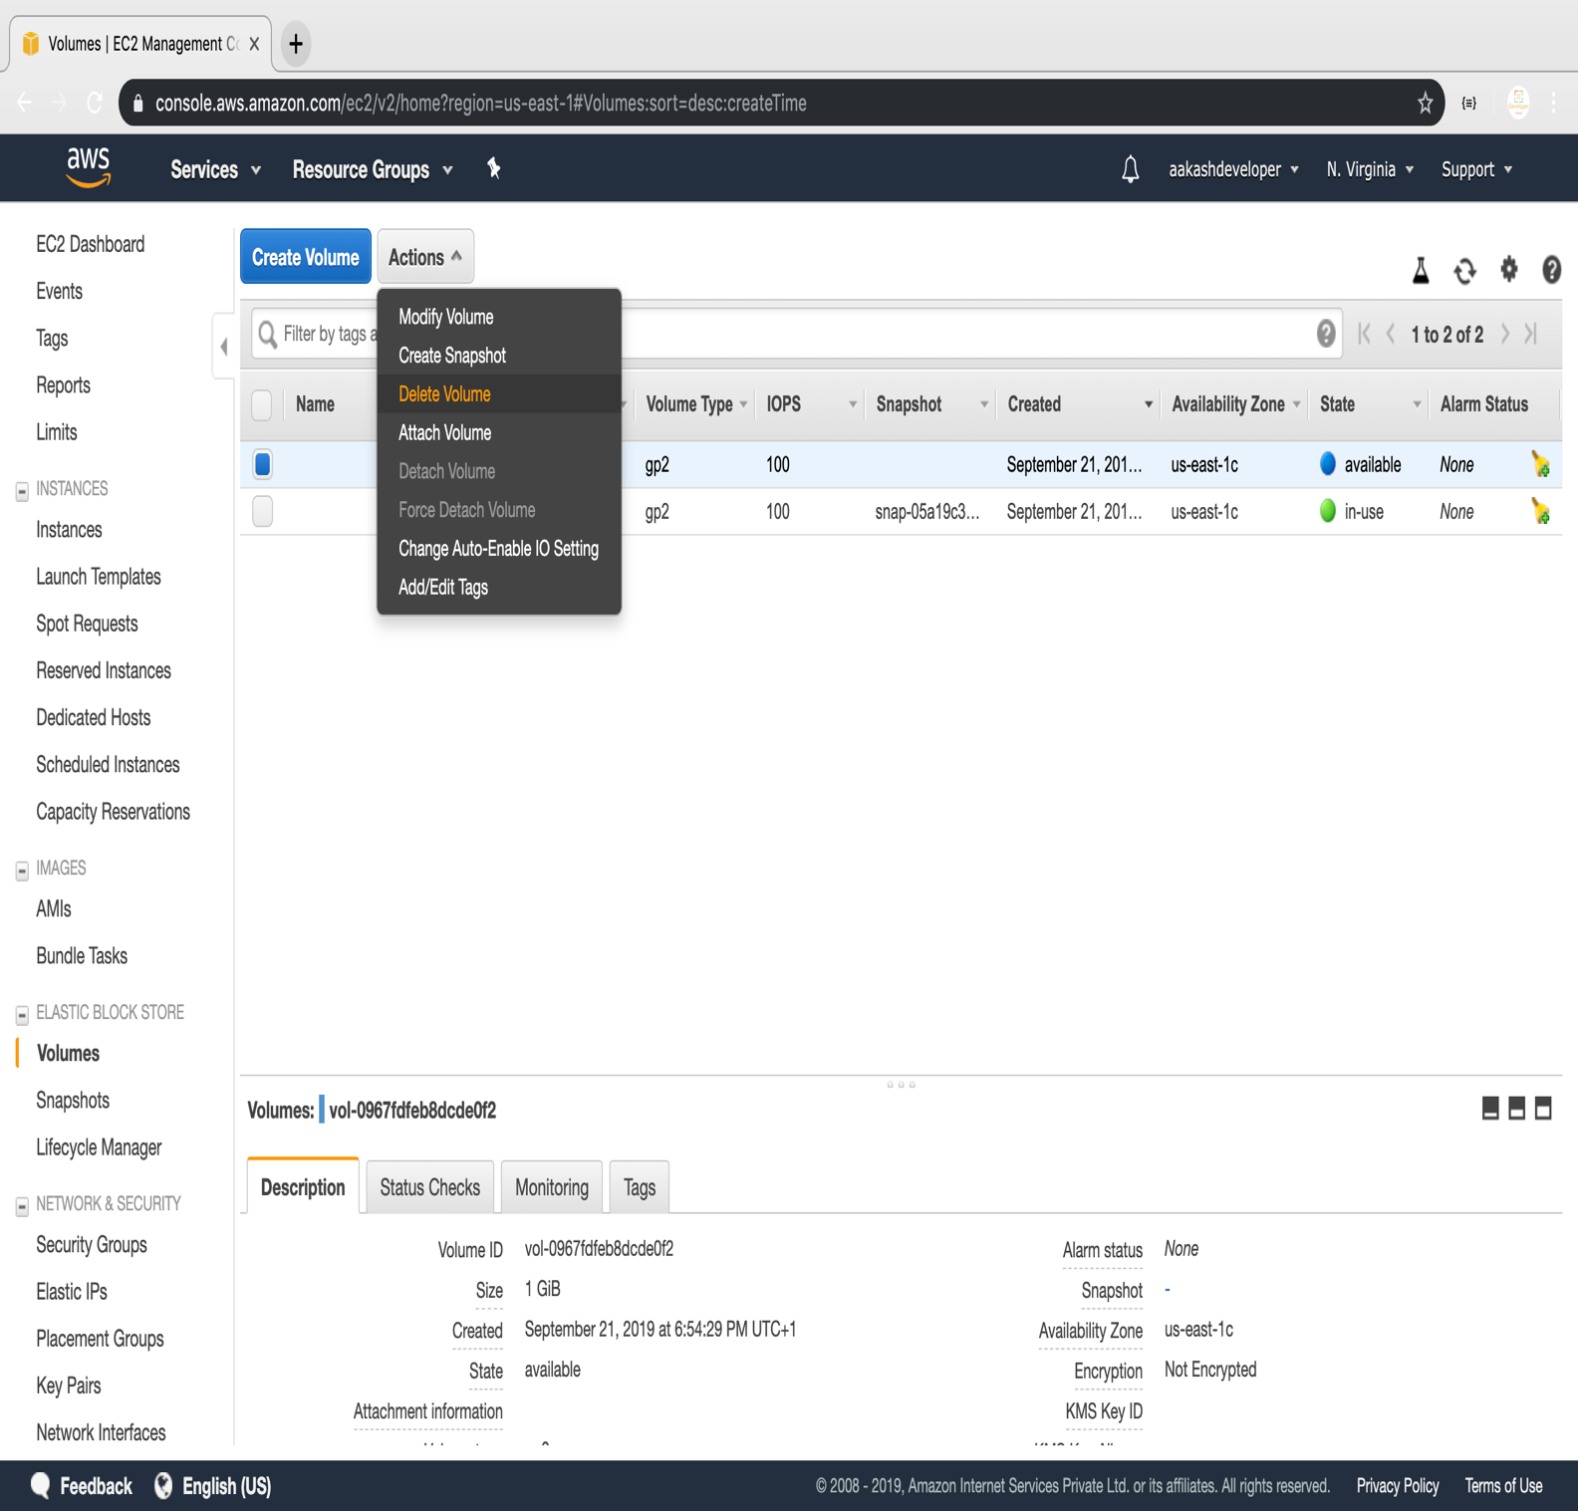

**Step 3.7.2:** Deleting the volume

